**ASSIGNMENT – 2**

**-Muralikrishna Maanukonda**

#importing the pandas, numpy and matplot libraries



#loading the data

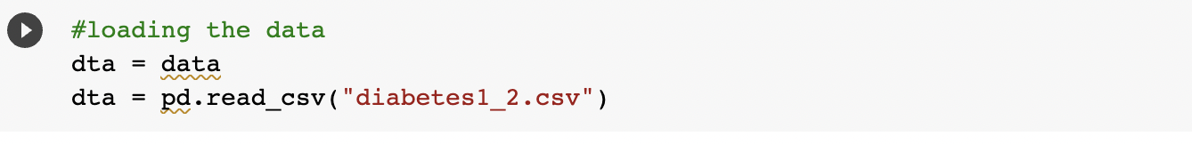

#printing the data

#setting the seed

#now taking the random samples of 25 observations and printing the samples, after that we are calculating the mean and max glucose of given samples

#the printed samples

#then calculating the mean and max glucose of the population

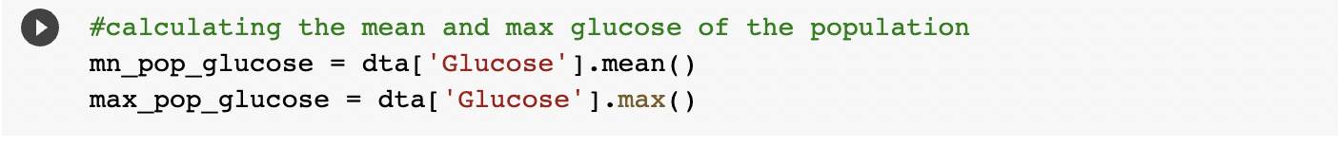

#plotting the results on the chart and comparing both

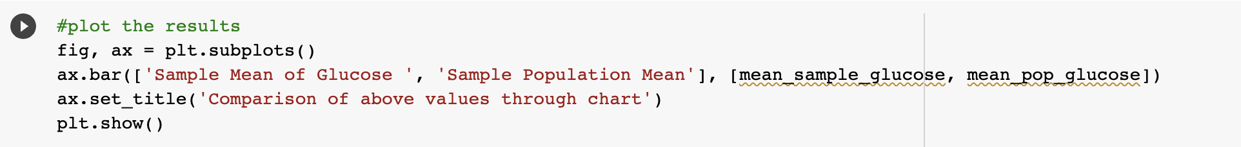

#calculating the 98th percentile of BMI for sample and population

#plotting the results



#Now using bootstrap (replace= True), creating 500 samples (of 150 observation each) from the  
population and finding the average mean, standard deviation and percentile for BloodPressure and comparing this with these statistics from the population for the same variable. And also creating the charts for comparision

Github link : <https://github.com/mm5hdmk/diabetes.git>